EXPERIMENT 7 A

DATA VISUALIZATION USING TABLEAU

Aim
To connect, analyze, visualize, and create interactive dashboards using Tableau with the student performance dataset.

Algorithm 1 – Connecting Data Source
Step 1 Open Tableau.
Step 2 Select Connect → Text File.
Step 3 Browse your CSV dataset.
Step 4 Open the dataset.
Step 5 Verify the imported data.
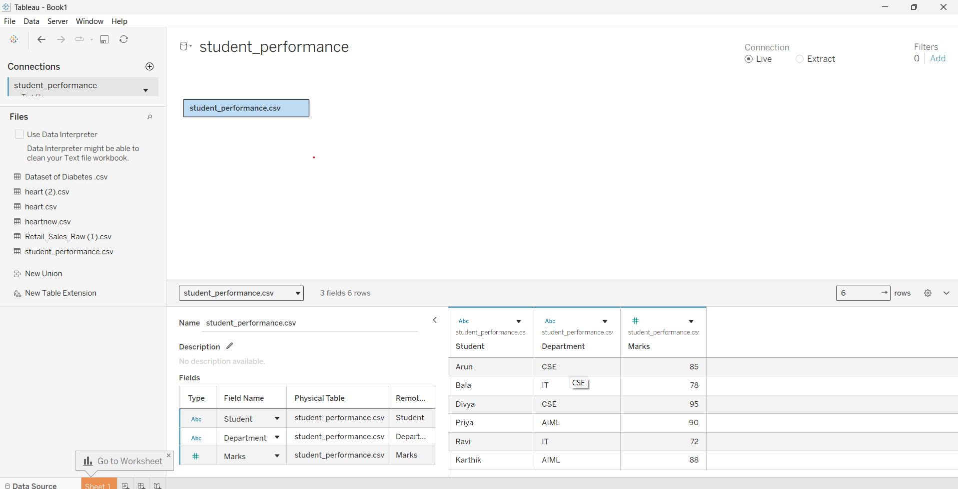

Algorithm 2 – Creating Worksheet
Step 1 Open Sheet 1.
Step 2 Drag Department to Columns.
Step 3 Drag Marks to Rows.
Step 4 Select the required visualization.
Step 5 Analyze the result.

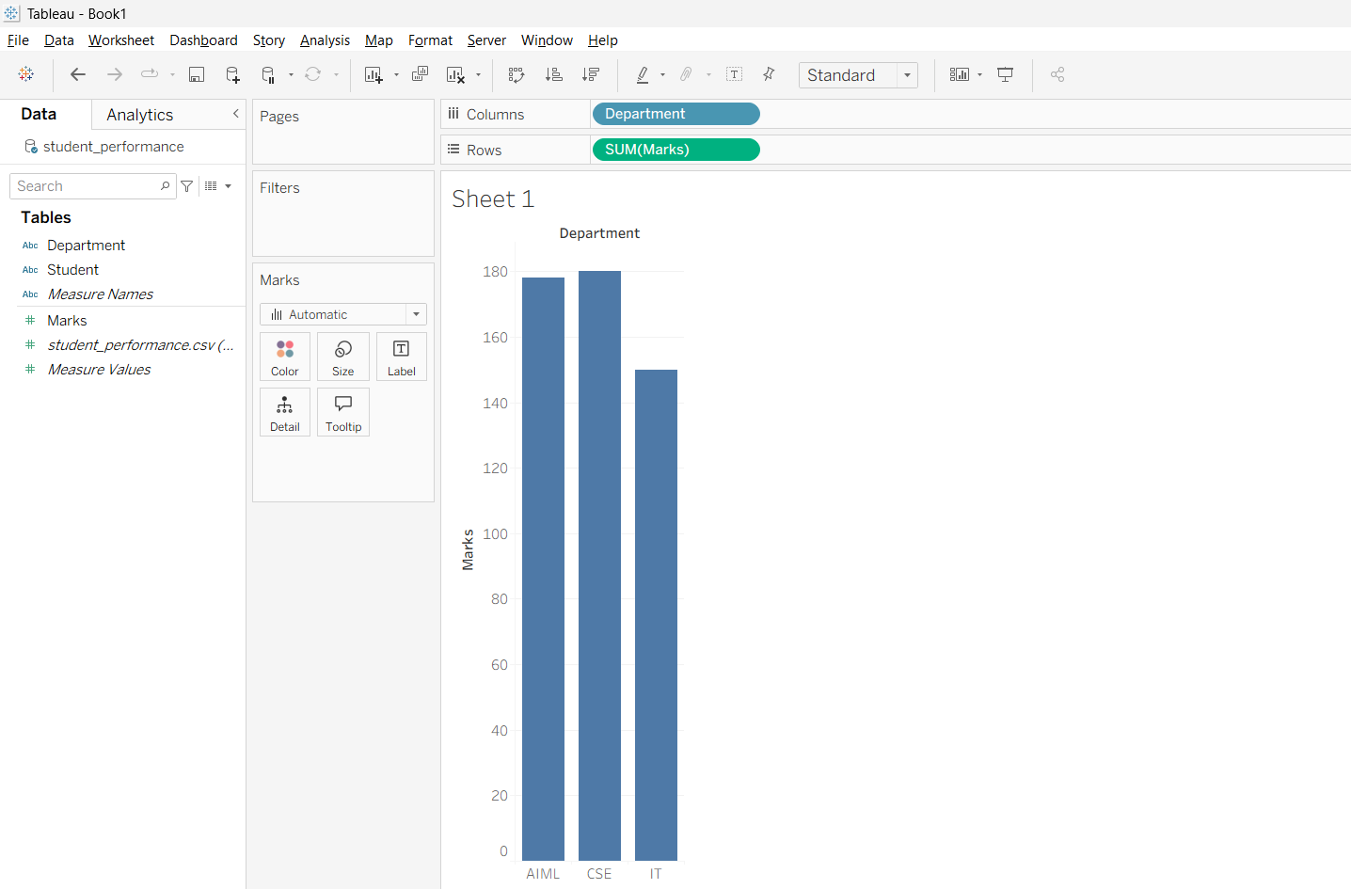

Algorithm 3 – Bar Chart Creation
Step 1 Drag Student → Columns.
Step 2 Drag Marks → Rows.
Step 3 Select Bar Chart.
Step 4 Show data labels.
Step 5 Analyze the marks obtained by students.

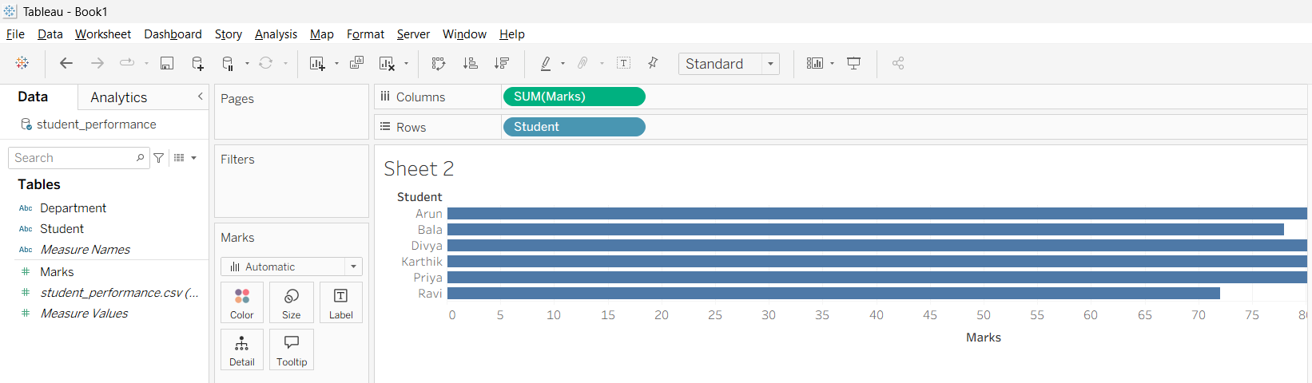

Algorithm 4 – Pie Chart Creation
Step 1 Drag Department to the view.
Step 2 Drag Marks to Angle.
Step 3 Select Pie Chart from Show Me.
Step 4 Enable labels.
Step 5 Analyze the department-wise marks contribution.

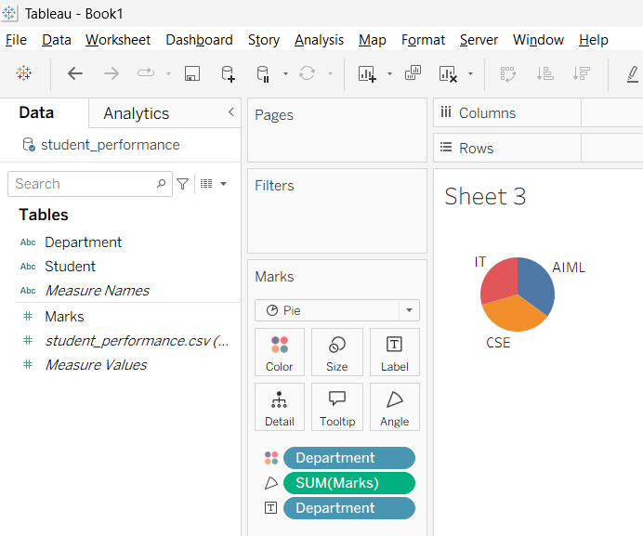

Algorithm 5 – Line Chart Creation
Step 1 Drag Student → Columns.
Step 2 Drag Marks → Rows.
Step 3 Select Line Chart.
Step 4 Apply suitable formatting.
Step 5 Analyze the performance trend.

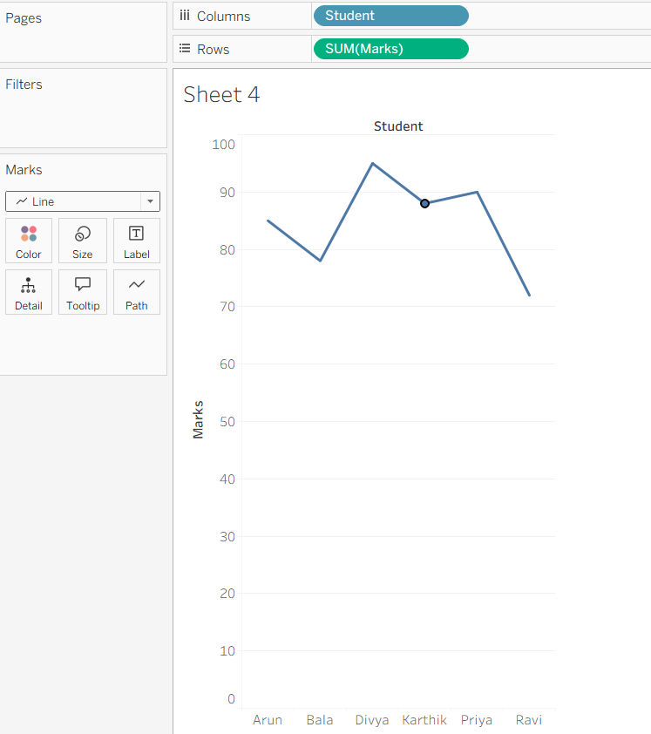

Result
Thus, the student performance dataset was successfully connected, analyzed, visualized, filtered, and presented using Tableau dashboards and interactive visualizations.

